**Amazon-Sales-2022-Data-Analysis**

#### Summary

This report presents a comprehensive analysis of Amazon sales data for the year 2022, focusing on sales performance, product preferences, fulfilment methods, customer segmentation, and geographical distribution. Key insights and actionable recommendations are provided to optimize business operations, enhance customer experience, and drive revenue growth.

#### Sales Overview

**Findings:**

* Monthly sales trend analysis revealed significant fluctuations, with notable peaks in March and October.
* The average monthly sales amount was identified, with some months falling below this average, indicating potential seasonal influences or promotional impacts.

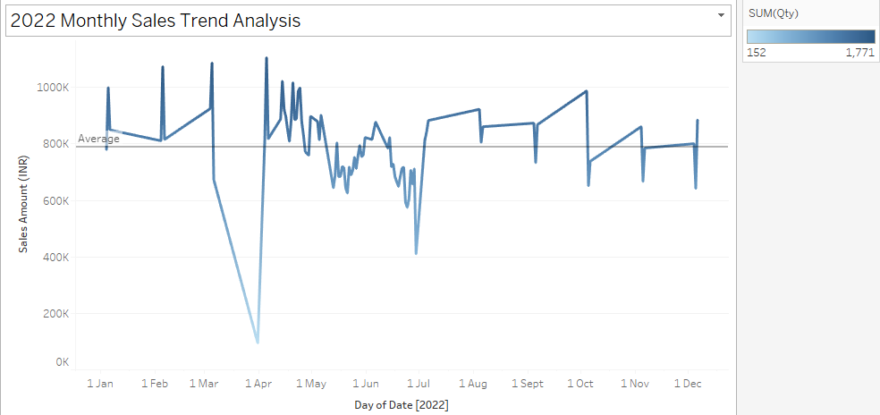

**Recommendations:**

* Implement targeted promotions during off-peak months to balance sales distribution.
* Analyze the factors contributing to peak sales months and replicate successful strategies.

#### Product Analysis

**Findings:**

* The most popular product categories included T-shirts, Shirts, and Blazers, with T-shirts having the highest sales volume.
* Smaller product categories such as Wallets and Watches showed lower sales volumes.

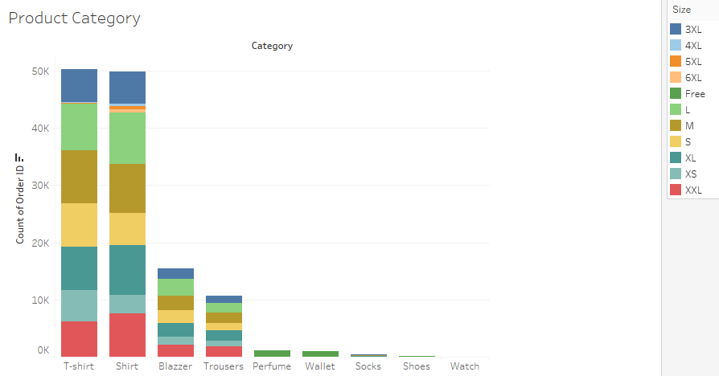

**Recommendations:**

* Increase inventory and marketing efforts for top-selling categories to capitalize on demand.
* Explore potential reasons for lower sales in smaller categories and consider promotional strategies to boost their performance.

#### Fulfillment Analysis

**Findings:**

* Amazon fulfillment methods showed a higher success rate in shipping compared to Merchant methods.
* The cancellation rate was significantly lower for Amazon-fulfilled orders.

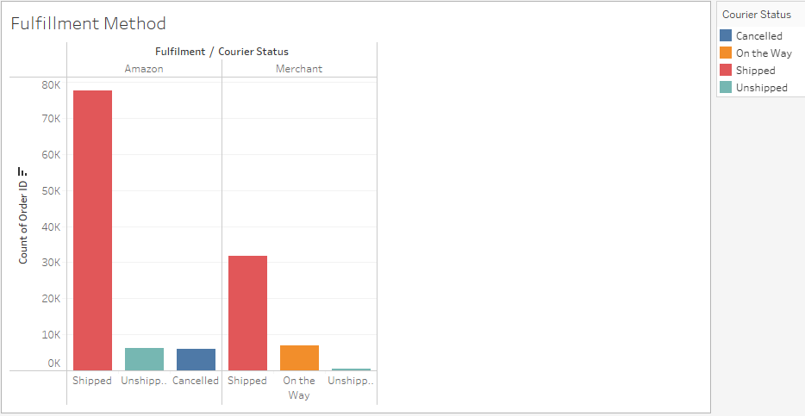

**Recommendations:**

* Prioritize Amazon fulfillment methods for critical products to ensure higher delivery success rates.
* Work with Merchant fulfillment partners to improve their shipping processes and reduce cancellations.

#### Customer Segmentation

**Findings:**

* Key customer segments were identified based on purchasing behaviour, with a significant proportion of repeat customers.
* Geographical segmentation showed higher sales concentrations in urban areas.

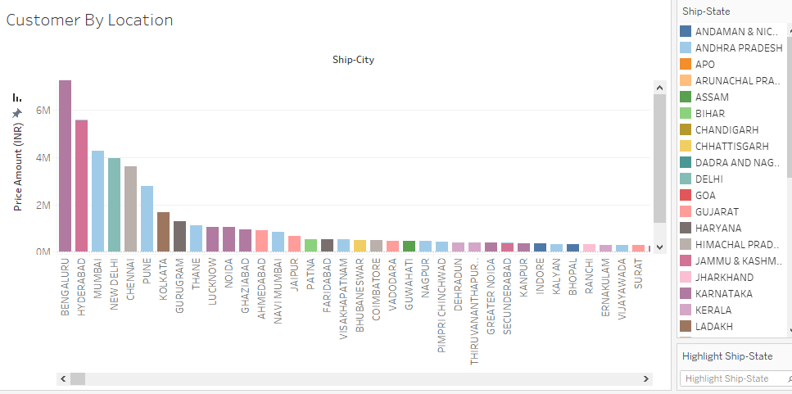

**Recommendations:**

* Develop loyalty programs to incentivize repeat purchases among key customer segments.
* Focus marketing efforts on high-sales urban areas while exploring strategies to penetrate less active regions.

#### Geographical Analysis

**Findings:**

* The geographical distribution of sales highlighted certain states as top performers, with others showing lower engagement.
* Major urban centers contributed significantly to the overall sales volume.

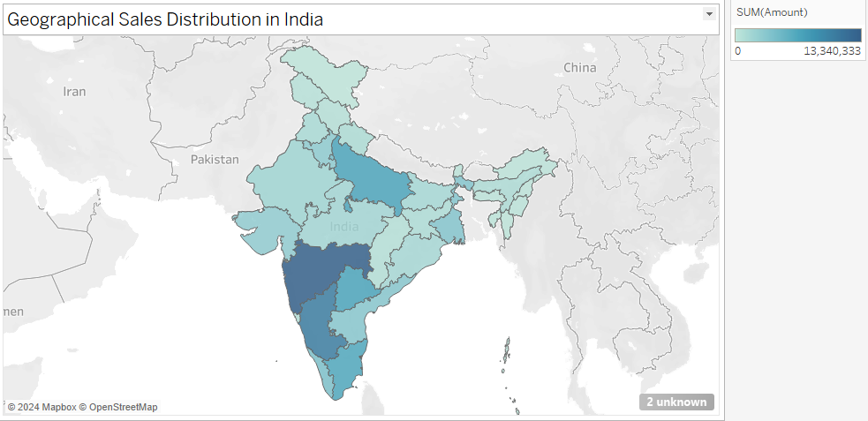

**Recommendations:**

* Tailor marketing campaigns to the top-performing states to maximize Return On Investment.
* Conduct market research in lower-engagement states to identify barriers and opportunities for growth.

#### Business Insights and Recommendations

**Overall Insights:**

* A well-rounded understanding of sales trends, product preferences, and customer behavior has been achieved.
* Strategic recommendations provided aim to enhance sales strategies, improve inventory management, and elevate customer service levels.

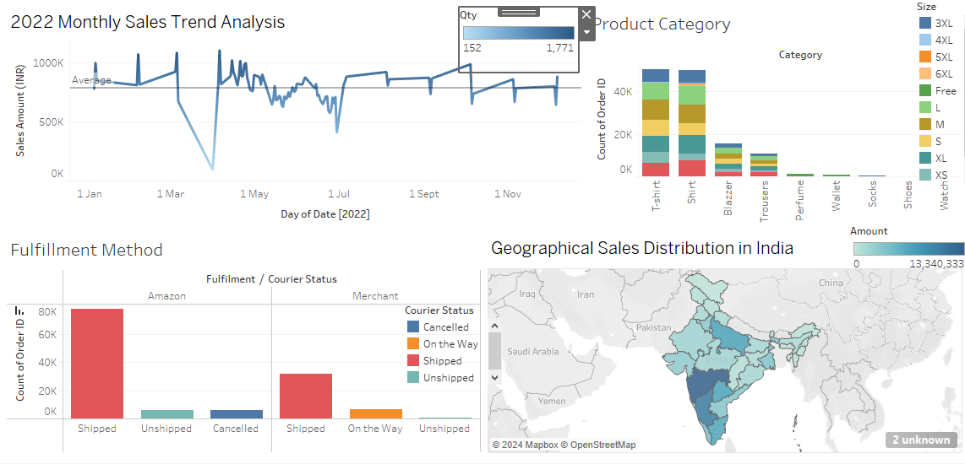

**Actionable Recommendations:**

* Implement seasonal promotions and targeted marketing strategies.
* Optimize inventory levels for high-demand products.
* Enhance fulfillment processes, particularly for merchant partners.
* Develop and promote loyalty programs.
* Focus on geographical areas with high sales potential and explore new markets.

### Conclusion

The detailed analysis of Amazon sales data has provided valuable insights into various aspects of the business. By leveraging these insights, the company can optimize its operations, improve customer satisfaction, and drive sustained revenue growth.